Learn Eden Energy Medicine!
In Wilmington, North Carolina

Foundations Energy Medicine Classes 2018-19
A Series of Four Classes – (4 mini beach vacations!)
Course Details
- No prerequisites required to enroll
- 4 extended weekends and supervised practice over 8 months
- A strong mix of demonstration & hands-on practice.
- 124 Continuing Education Credits available for massage therapists.

Imagine being able to improve your own health and well-being! Foundations Classes are hands-on classes that teach you the fundamentals of Eden Energy Medicine (EEM), based on Donna Eden’s revolutionary work on balancing and harmonizing energy systems for optimal physical, mental, emotional and spiritual well-being. Some topics covered include: Energy Testing, techniques for balancing Meridians and Electrics system, clearing Chakras and energizing Radiant Circuits!
For those with no energy experience:
Learn new tools for your own health and well-being toolbox. And take away techniques you can use with family and friends!
For psychotherapists, coaches, massage therapists, nurses, doctors:
Learn numerous ways to integrate Eden Energy Medicine into your professional health care practice with improved results!
For becoming certified in EEM:
This is the first year of the two-year Eden Energy Medicine Certification Program.
Dates – April 26-29, July 12-15, September 27-30, Dec. 13-16, 2018
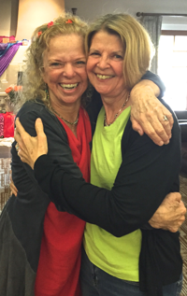
Register online at www.innersource.net or www.choicefulliving.com
Cell phone: 928-925-8150 or Email suzi@choicefulliving.com

“Energy Medicine is the oldest, safest, most organic, most accessible, most affordable medicine there is!”
Donna Eden
What students are saying:
After taking Suzi’s Energy Medicine classes, I have been able to incorporate an energy routine into my days. I like the idea of managing my energy to enhance my own health in a variety of ways.
I experience Suzi as a kind and generous soul who loves learning and teaching as she integrates her knowledge of energy medicine into her own life, and the lives of others.
.
Taught by Certified Teacher and Eden Energy Medicine Advanced Practitioner, Suzi Snyder, Ph.D. Suzi’s background as an educator specializing in how people learn combined with her energy medicine expertise, creates fun and creative ways for learning how to boost your own health & well-being & family and friends!

